AutoManager: Vehicle & Sales Management System
~T Deeraj(vtu24675)

1. DATABASE OVERVIEW
Database Name: carshowroom
Description:
The AutoManager database manages vehicle inventory, customer details, and salesperson information for a car showroom. It supports sales tracking, reporting, and transaction management.
Tables Used:
- customers
- salespeople
- vehicles

2. BASIC DATABASE COMMANDS
SHOW DATABASES;
USE carshowroom;
SHOW TABLES;
DESC customers;
DESC salespeople;
DESC vehicles;
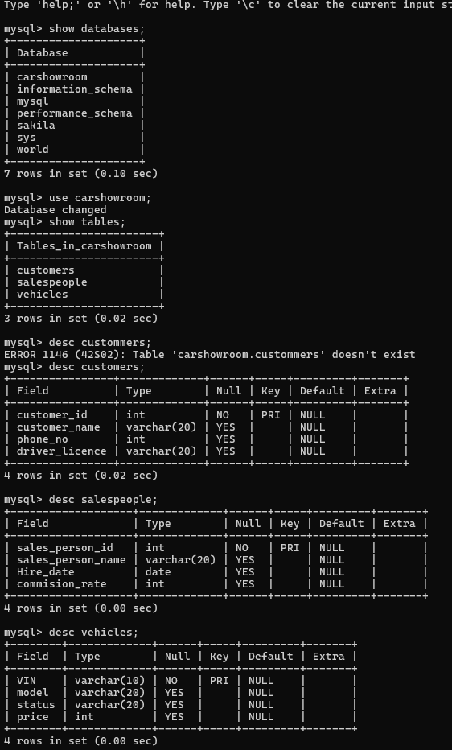

3. DDL – DATA DEFINITION LANGUAGE

3.1 CREATE TABLE
CREATE TABLE customers (
customer_id INT PRIMARY KEY,
customer_name VARCHAR(20),
phone_no INT,
driver_licence VARCHAR(20)
);
CREATE TABLE salespeople (
sales_person_id INT PRIMARY KEY,
sales_person_name VARCHAR(20),
hire_date DATE,
commision_rate INT
);
CREATE TABLE vehicles (
VIN VARCHAR(10) PRIMARY KEY,
model VARCHAR(20),
status VARCHAR(20),
price INT
);

3.2 ALTER TABLE
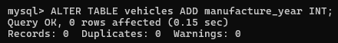

3.3 DROP TABLE
DROP TABLE vehicles;

3.4 TRUNCATE TABLE
TRUNCATE TABLE customers;

4. DML – DATA MANIPULATION LANGUAGE

4.1 INSERT
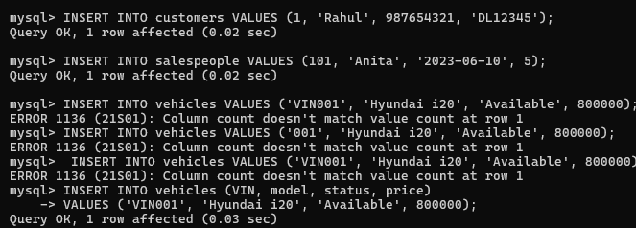

4.2 SELECT
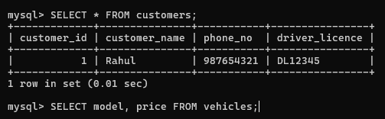

4.3 UPDATE
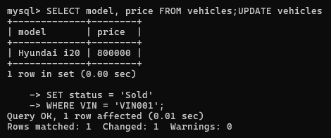

4.4 DELETE
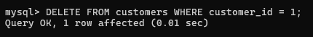

5. DQL – DATA QUERY LANGUAGE

5.1 AGGREGATE FUNCTIONS
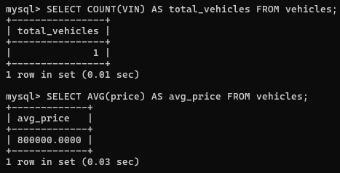

5.2 GROUP BY & ORDER BY
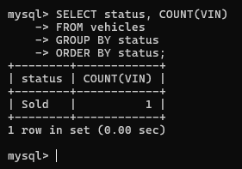

6. TCL – TRANSACTION CONTROL LANGUAGE

6.1 COMMIT
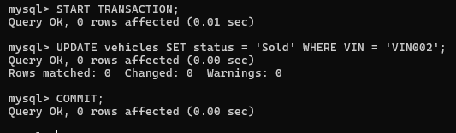

6.2 ROLLBACK
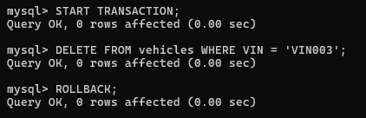

6.3 SAVEPOINT
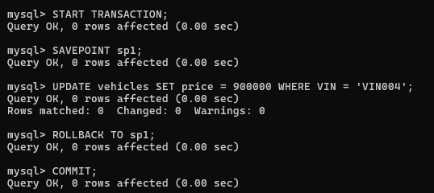

7. JOINS

7.1 INNER JOIN
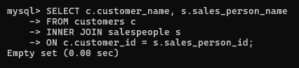

7.2 LEFT JOIN
SELECT c.customer_name, v.model
FROM customers c
LEFT JOIN vehicles v
ON c.customer_id = v.price;

7.3 RIGHT JOIN
SELECT s.sales_person_name, v.model
FROM salespeople s
RIGHT JOIN vehicles v
ON s.sales_person_id = v.price;

8. VIEW
CREATE VIEW available_vehicles AS
SELECT model, price
FROM vehicles
WHERE status = 'Available';

9. TRIGGER
